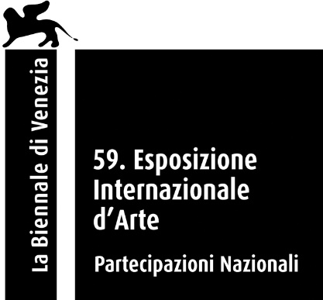

Pavilion of Poland
at the 59th International Art Exhibition — La Biennale di Venezia

For the first time in the over-120-year history of the International Art Exhibition of La Biennale di Venezia, a Roma artist is representing a national pavilion. The project Re-enchanting the World by Małgorzata Mirga-Tas, prepared specifically for the Polish Pavilion at the Biennale Arte 2022, is an attempt to find the place of the Roma community in European art history. The exhibition, which consists of twelve large-format textiles installation, alludes to the famous ‘Hall of the Months’ fresco series from the Renaissance Palazzo Schifanoia in Ferrara, Italy, one of the most mysterious buildings in European architecture. The project proposed by curators Wojciech Szymański and Joanna Warsza was the winner of a competition organised by Zachęta — National Gallery of Art.

The exhibition is accompanied by a catalogue edited by Wojciech Szymański and Joanna Warsza, which, in addition to the curators’ texts includes essays by specially invited writers (Ali Smith, Damian Le Bas, scholar Ethel Brooks), and poems by Teresa Mirga and Jan Mirga. The catalogue is co-published by Archive Books and ERIAC, and can be also downloaded as a pdf file for free at labiennale.art.pl.

Małgorzata Mirga-Tas is currently one of the most famous names in the Polish art world, and her international reputation is on the rise. This Polish-Roma artist and activist is representing Poland at the Biennale Arte 2022, challenging stereotypes, presenting an insightful, unprejudiced picture of the Roma community, and drawing attention to the role women have played in Romani history. Her works are created from pieces of fabric by, as she puts it, ‘throwing the material into the picture’. Her large-format collages often use pieces of the wardrobe of the subjects portrayed: fragments of skirts, scarves or shirts, which become literal carriers of history.

The monumental installation which fills the space of the Polish Pavilion consists of twelve large-format textiles drawing from the famous cycle of frescoes from the Renaissance Palazzo Schifanoia. The name of the villa in Ferrara, Italy, comes from the phrase schivar la noia, meaning ‘escape from boredom’. The paintings, which date back more than 500 years, depict Olympian gods, zodiac signs and decans, as well as scenes from court life in Ferrara at the time. The symbols of the palace interior, as well as its layout and form, are the artist’s visual and ideological reference points. Each of the twelve fabrics presented in the Pavilion are divided into three horizontal sections.

The upper section depicts the history of Romani peregrinations across Europe, referencing the engravings of Lorraine printmaker Jacques Callot. Created in the seventeenth century, these engravings are full of anti-Roma stereotypes. The artist disenchants this painful narrative and draws on historical works to create her own large-scale collages, showing the rich world of the Romani past and mythology.

The middle section is an archive of Roma history, built from a female perspective. In recent years, Mirga-Tas has created a number of works dedicated to the important women in her life, making up the Herstories series. Portraits of representatives of the Roma community are complemented by symbols borrowed from tarot cards and zodiac signs from Palazzo Schifanoia. Combining images of real women with magic and astrology, she transforms them into symbolic guardians of fate, goddesses and prophetesses.

The lower section consists of twelve paintings depicting contemporary everyday life in the artist’s home village in Poland, Czarna Góra, and the areas to which she is most closely connected — Podhale, in the south of Małopolska, and the multicultural Spisz. They mainly show women, their relationships, alliances and shared activities.

The artist constructs her own version of the Renaissance palace interior in the Polish Pavilion; in reference to the title of this year’s Biennale Arte (The Milk of Dreams), she creates a magical world, a kind of temporary and interim shelter for the viewer — an asylum offering hope and respite. The ‘re-enchantment’ of the title, inspired by Silvia Federici’s book Re-enchanting the World: Feminism and the Politics of the Commons (2018), is a non-violent process to change the world’s errant paths, lift the evil spell from the world, and help regain a sense of community and rebuild relationships with others.

Re-enchanting the World is based on the idea of transnationality, cyclicality and the change of appropriated meanings, proposing a new narrative about the constant cultural migration of images and mutual influences between Roma, Polish and European cultures. The concept of the wandering of images comes from art historian Aby Warburg, who explained it as the life after life of images. Warburg was interested in the sudden appearance of certain images in a certain place and time after a long period of absence. Following this path, Małgorzata Mirga-Tas uses representations from Schifanoia, but transforms key motifs in European art history by inserting representations of Polish–Roma culture and reversing the stereotypical narrative.

A documentary film devoted to Małgorzata Mirga-Tas, directed by Anna Zakrzewska (produced by Kijora Film and Zachęta) is being made on the occasion of the exhibition. The film portrait of the artist not only profiles her and Roma traditions, it also records the collective process of creating work for the Polish Pavilion. The film is scheduled to be released in autumn 2022.

POLISH PAVILION AT THE 59TH INTERNATIONAL ART EXHIBITION — LA BIENNALE DI VENEZIA
Venice, 23 April–27 November 2022

Małgorzata Mirga-Tas
Re-enchanting the World

curators: Wojciech Szymański and Joanna Warsza

organiser: Zachęta — National Gallery of Art
Polish Pavilion commissioner: Janusz Janowski (from 2022), Hanna Wróblewska (till end of 2021) / Zachęta — National Gallery of Art
Polish Pavilion office: Ewa Mielczarek, Joanna Waśko (deputy commissioner)

more about the exhibition: labiennale.art.pl

Polish participation at the 59th International Art Exhibition of La Biennale di Venezia was made possible through the financial support of the Ministry of Culture and National Heritage of the
Republic of Poland.

exhibition partners: Adam Mickiewicz Institute, European Roma Institute for Arts and Culture (ERIAC)

publication supported by the DAAD Artists-in-Berlin Program with funds from the German Federal Foreign Office

collaboration: Polish Institute in Rome media patronage: Vogue Poland

media contact:
Joanna Andruszko / communications department, Zachęta — National Gallery of Art
j.andruszko@zacheta.art.pl, +48 693 974 686

Joanna Waśko / Polish Pavilion office, Zachęta — National Gallery of Art
j.wasko@zacheta.art.pl

BIOGRAPHICAL NOTES

artist

Małgorzata Mirga-Tas is a Polish-Roma artist and activist. In her works, sculptures, paintings, spatial objects and large-format textiles, she addresses anti-Romani stereotypes and engages in building an affirmative iconography of Roma communities. She graduated from the Faculty of Sculpture at the Academy of Fine Arts in Krakow (2004). She participated in several dozen individual and group exhibitions, including the 11th Berlin Biennale (2020), the Art Encounters Biennial in Timişoara (2019, 2021), 3rd Autostrada Biennale in Prizren (2021), while her works were displayed at the Moravian Gallery in Brno (2017), the Center of Polish Sculpture in Orońsko (2020), Museum of Modern Art in Warsaw (2020), or Rautenstrauch-Joest-Museum in Cologne (2021), among others. She lives and works in Czarna Góra, Poland.

curators
Wojciech Szymański, art historian and art critic, independent curator. Assistant professor at the Institute of Art History, University of Warsaw, author of several dozen articles, editor and author of monographs and exhibition catalogues, principal investigator and researcher in a number of Polish and international scientific projects; since 2019 he has been editor-in-chief of “Ikonotheka” journal. Curator of numerous art shows, with special interest in contemporary Roma art and its presence in the global art world. He curated the following shows featuring the works of Małgorzata Mirga-Tas: Kali Berga (Krakow 2016, Berlin 2017); The Right to Look (Krakow 2018), 29. Exercises in Ceroplastics (Orońsko 2020), Out of Egypt (Białystok 2021). He is a member of the International Association of Art Critics (AICA). He lives in Krakow.
Joanna Warsza is an independent curator, editor, and Program Director of CuratorLab at Konstfack University of Arts in Stockholm. Recently she co-curated, together with Övül Ö. Durmusoglu, Die Balkone in Berlin, the 3rd Autostrada Biennale in Kosovo, and the 12th Survival Kit in Riga. She was also the Artistic Director of Public Art Munich 2018, curator of the Georgian Pavilion at the Biennale Arte 2013, head of the public program of Manifesta 10 and associate curator of the 7th Berlin Biennale at the invitation of Artur Żmijewski. Her recent publications include Red Love. A Reader on Alexandra Kollontai (with Maria Lind and Michele Masucci, 2020), and And Warren Niesłuchowski Was There: Guest, Host, Ghost (with Sina Najafi; published by Cabinet Books and Museum of Modern Art Warsaw, 2020). Originally from Warsaw, she lives in Berlin.

organizer
Zachęta — National Gallery of Art in Warsaw, is the organizer of the exhibitions in the Polish Pavilion both for Art and Architecture Exhibitions of La Biennale di Venezia, as well as the custodian of the building. The gallery’s director acts as the pavilion commissioner. Poland has its own exhibition pavilion, which is located in Giardini — one of the two main exhibition venues of La Biennale di Venezia.

IMAGES
1
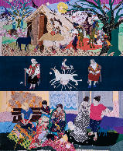
Małgorzata Mirga-Tas, Re-enchanting the World (March), 2022, textile installation (fragment), 462 x 387 cm. Photo: Daniel Rumiancew.
2
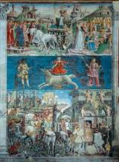
Hall of the Months, Museo Schifanoia, Ferrara, courtesy Musei di Arte Antica di Ferrara. Photo: Daniel Rumiancew
3
Małgorzata Mirga-Tas. Photo: Ina Lekiewicz

4
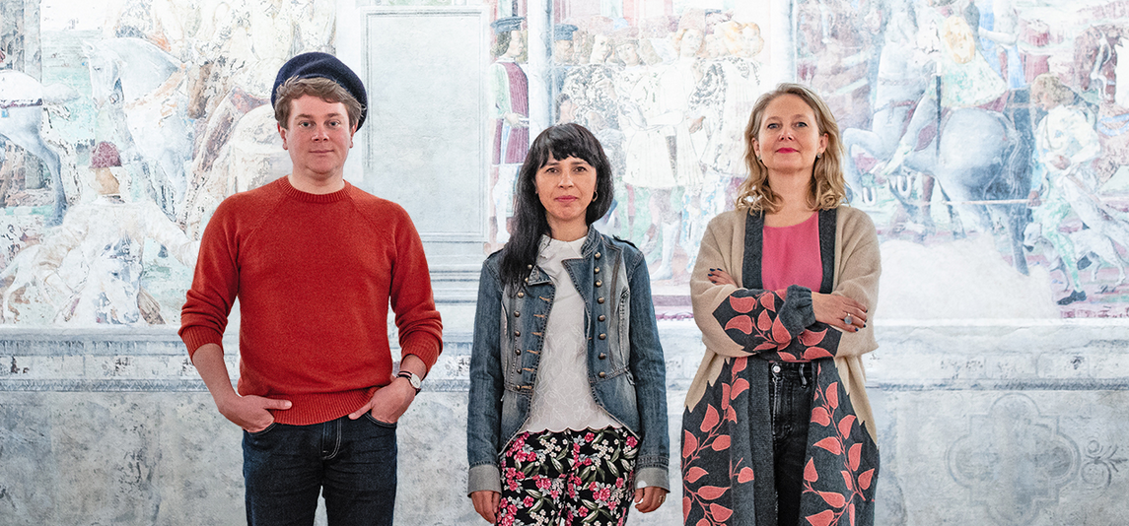
Authors of the Re-enchanting the World exhibition standing against frescoes in the Palazzo Schifanoia at Ferrara, Italy, 2021 (from left: Wojciech Szymański, Małgorzata Mirga-Tas, Joanna Warsza). Photo: Daniel Rumiancew.
5,6,7
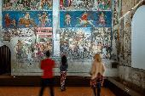 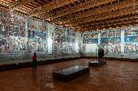 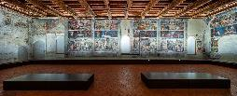
Hall of the Months, Museo Schifanoia, Ferrara, courtesy Musei di Arte Antica di Ferrara. Photo: Daniel Rumiancew
8,9,10,11,12
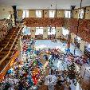 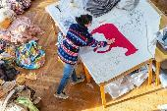 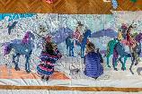 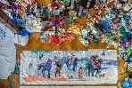
Preparations for the exhibition Re-enchanting the World in the studio of Małgorzata Mirga-Tas, Zakopane, 2021. Photo: Daniel Rumiancew.

Images courtesy Zachęta — National Gallery of Art.

